LAPTOP BRANDS - NEW LAPTOP PAGE - VIRAJIT.COM

- Use dark black color for text instead of grey color
- Increase the font size by a least 2 to 4 spaces to make it easy to read

_________________________________________________________________

Remove this strip. Also reduce the gap / height between the home section and second section on the page.

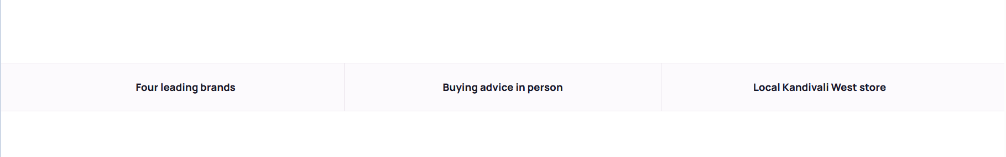

_________________________________________________________________

Replace second line - add partner credentials with this text. And replace text of dell, acer and others with the actual logos.

- Authorised MSi Royal Partner
- Authorised 𝗘𝗽𝘀𝗼𝗻 𝗖𝗲𝗿𝘁𝗶𝗳𝗶𝗲𝗱 𝗖𝗵𝗮𝗻𝗻𝗲𝗹 𝗣𝗮𝗿𝘁𝗻𝗲𝗿
- Authorised DELL Loyalty Partner
- Authorised ACER Laptop Dealer

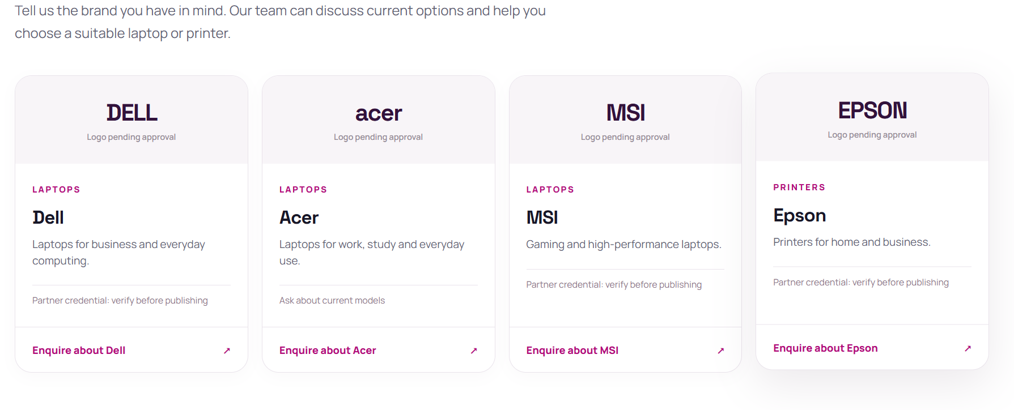
_________________________________________________________________

For Why Buy From VirajIT - use the photo shared below of mom and som with a gaming laptop.
